COE848 Lab 2 – ERD Report

Name: Jia fei Lin

Student Number: 500782008

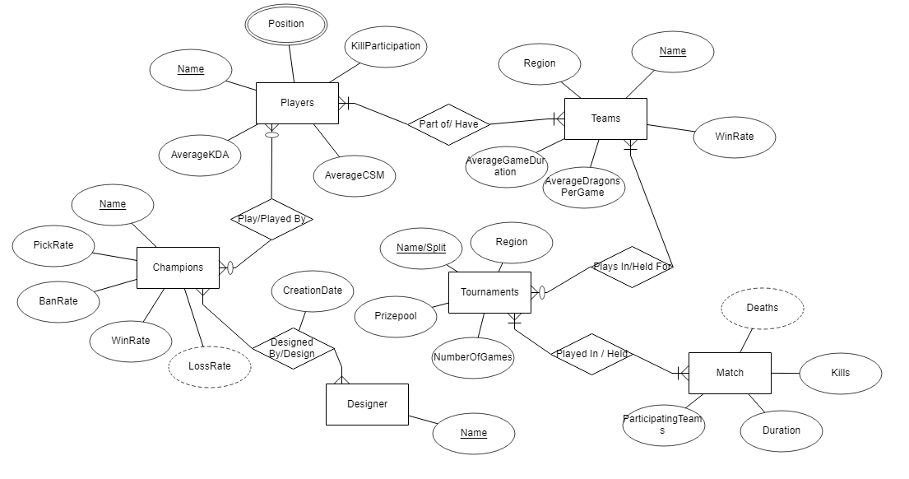

|  |  |
| --- | --- |
| Players: This entity holds the person’s statistics | |
| Name | Person’s in-game name |
| Position | Lane that the person plays |
| Average KDA | Average kills/deaths/assists ratio |
| Average CSM | Average creep score per minute |
| Kill Participation | Average Kill participation |

|  |  |
| --- | --- |
| Champions: This entity holds the character’s pre/post game statistics | |
| Name | Name of the character |
| Pick Rate (%) | Number of games played in / Total games |
| Ban Rate (%) | Number of games banned / Total games |
| Win Rate (%) | Number of wins / Total games |
| Loss Rate (%) [Derived from (100% - Win Rate )] | Loss percentage of champion |

|  |  |
| --- | --- |
| Teams: This entity holds the team’s details | |
| Name | Name of organization |
| Region | Region the team plays in |
| Win Rate | Number of wins / Total games |
| Average Dragons Per Game | Sum of dragons per game/ Total games |
| Average Game Duration | Sum of duration of games / Total games |

|  |  |
| --- | --- |
| Tournaments: This entity holds the tournament’s details | |
| Name/Split | Name of the tournament with the split its played in |
| Region | Region the tournament is held in |
| Number of Games | Total number of matches played |
| Prizepool | Total amount of money to be won |

|  |  |
| --- | --- |
| Match: This entity holds the match’s details | |
| Participating Teams | Name of teams that played in this match |
| Duration | The total time of the game |
| Kills | Total accumulated kills per team |
| Deaths [Derived from kills] | Total accumulated deaths per team |

|  |  |
| --- | --- |
| Designer: This entity holds the creator of the champion’s details | |
| Name | Name of the creator |

|  |  |  |
| --- | --- | --- |
| Relationships | | |
| Players – Teams | Many to Many | Each player will be part of one team at a time, however they may have been part of different teams previously. Each team will have many players. |
| Players - Champions | Many to Many | Each player can play many champions, and each champion may be played by different players. |
| Teams – Tournaments | Many to Many | Each team can be part of many tournaments, and each tournament will need many teams |
| Tournaments - Match | Many to Many | Each tournament will hold many matches, and each match can be played in many tournaments |
| Champions – Designer | Many to Many | Each champion can be designed by many designers, and each designer can design multiple champions |